EXPERIMENT-01

Aim: Install Android Studio on your Linux machine. Create a new Android project and understand the project structure. Familiarise yourself with the Android Virtual Device (AVD) manager and create a virtual device.

Theory:
This practical demonstrates how to set up the Android development environment using Android Studio. It includes installing the IDE, understanding project structure, and configuring the Android Virtual Device (AVD) for testing applications. It helps in understanding how Android projects are created and executed.

Installation of Android Studio
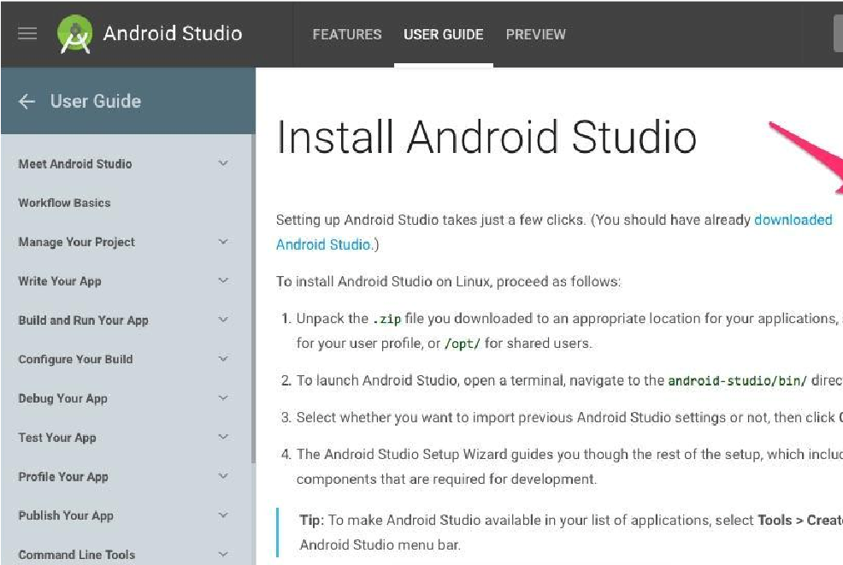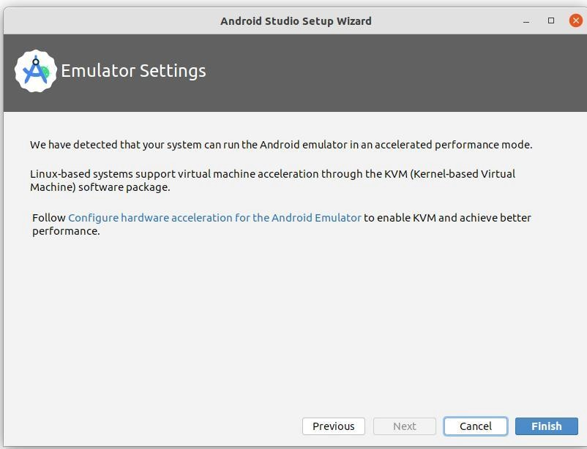
- Download Android Studio from the official website
- Extract the downloaded file
- Run studio.sh from the terminal
- Complete the setup wizard and install the required SDK components

Creating a New Android Project
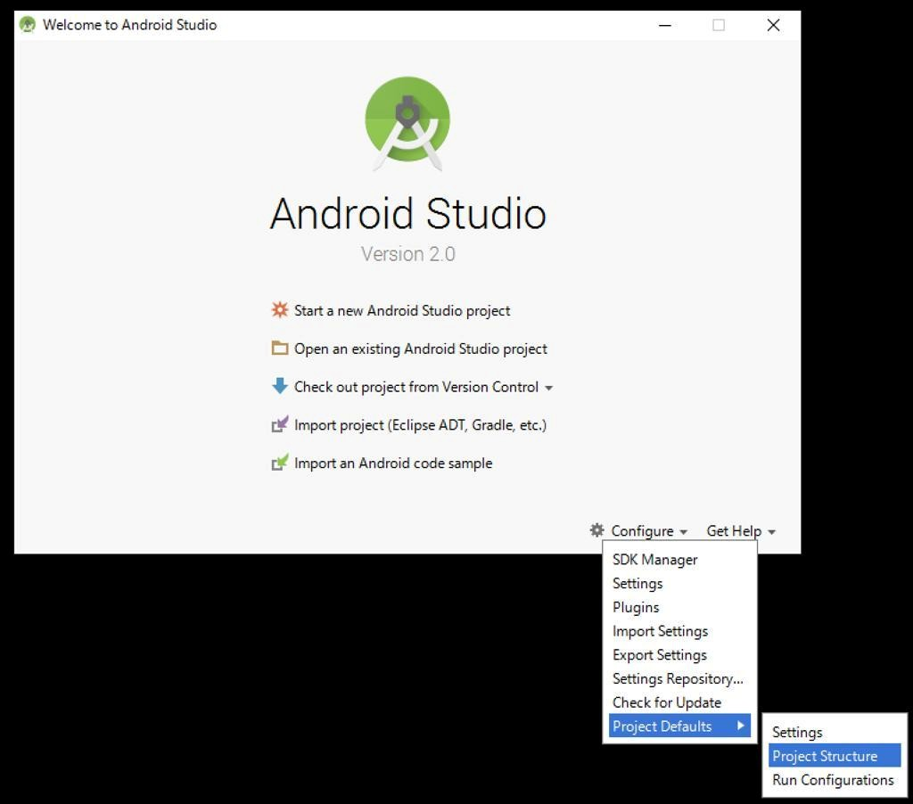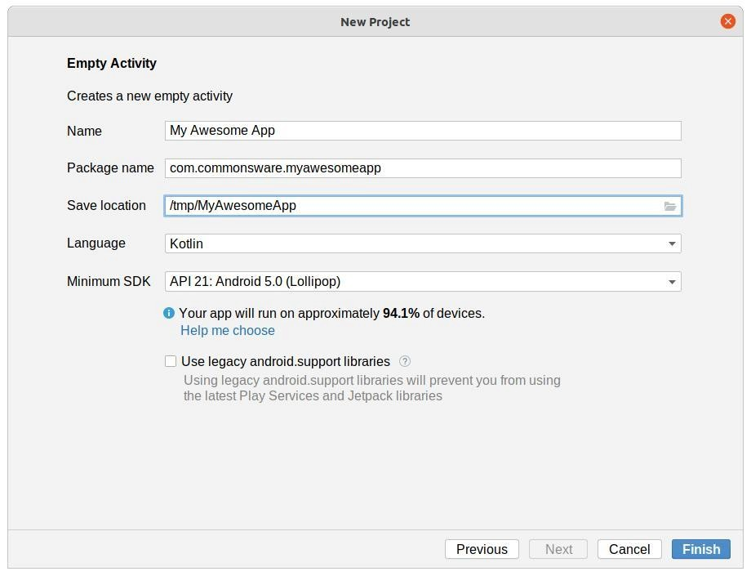
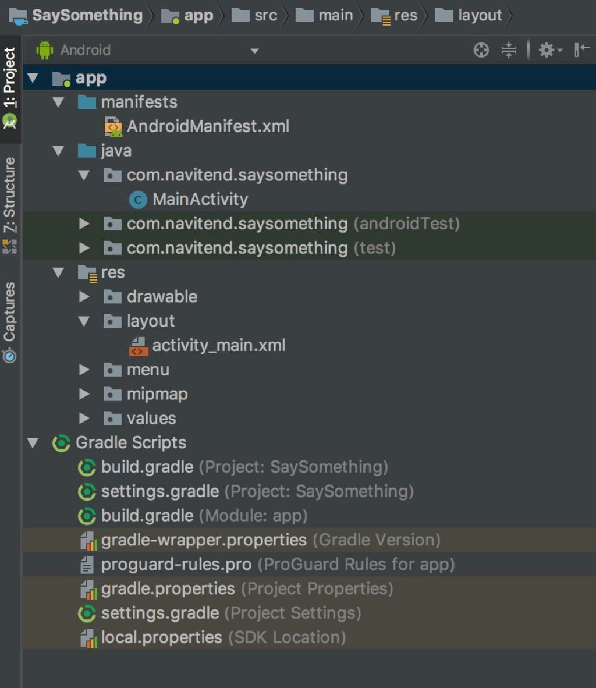
- Open Android Studio
- Click New Project
- Select Empty Activity
- Choose language (Java/Kotlin)
- Click Finish

Understanding Project Structure
- Manifests → Contains AndroidManifest.xml (app configuration)
- java folder → Contains source code (MainActivity.java)
- res folder → Contains resources (layouts, images, strings)
- Gradle Scripts → Handles dependencies and build configuration

Android Virtual Device (AVD) Manager

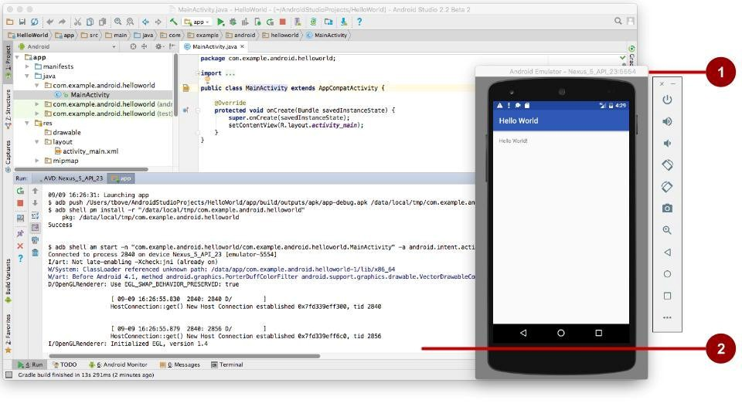
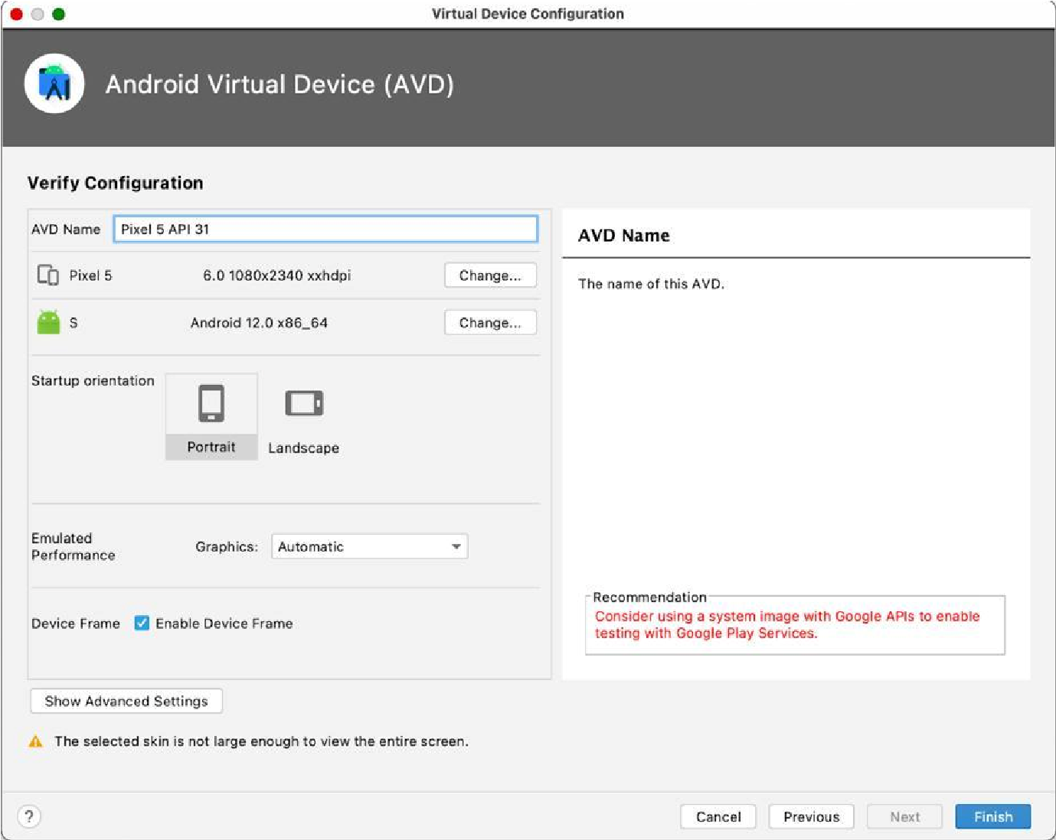

- Open AVD Manager in Android Studio
- Click Create Virtual Device
- Select device (e.g., Pixel)
- Choose system image (Android version)
- Click Finish and run the emulator

Conclusion:
The Android development environment was successfully set up on Linux. The project structure and AVD Manager were explored, enabling application development and testing.

